Mavzu: Choyshablar tikish

Reja:

1. Choyshablarni gazlamalardan bichish.
2. Choyshablarni bantovkalarda taxlab tikish.

Kravat o`lchamlari : b0``yi 2 m, eni 180 sm, balandligi 50 sm. 480 sm

Gazlama kerak bo`ladi.

|  |  |  |
| --- | --- | --- |
| |  | | --- | | 2m 2m  180 sm | |  |
| 1m |

Balandlik uchun 50sm dan o`lchamlar kerak bo`ladi:

280 sm

|  |  |  |  |  |  |
| --- | --- | --- | --- | --- | --- |
| 50sm | 50sm | 50sm | 50sm | 50sm | 50sm |

Ketma-ketlikda bir-birlari biriktirib tikiladi.

50 sm

|  |
| --- |
| 16.80 sm eni |

180 sm gazlamadan qolgan 80 sm gazlamani 50 sm dan qilib bichib olamiz:

280 sm

50 sm

|  |
| --- |
| 80 sm |
| 2 m |

Choyshabni yonlariga 50 sm bo`y gazlamalarni ketma-ket birlashtiramiz.

80 sm

|  |
| --- |
| 16.80 sm |

17.60 sm

180 sm +180 sm +2 m = 580 sm

580 sm *3 = 17.40 sm

17.40 sm ni 3/1 taxlamda … taxlaymiz

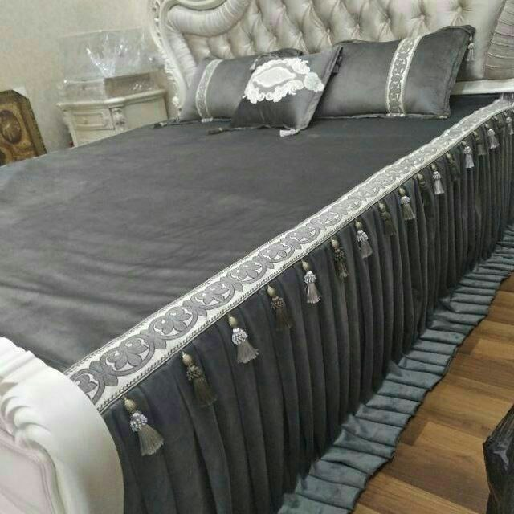 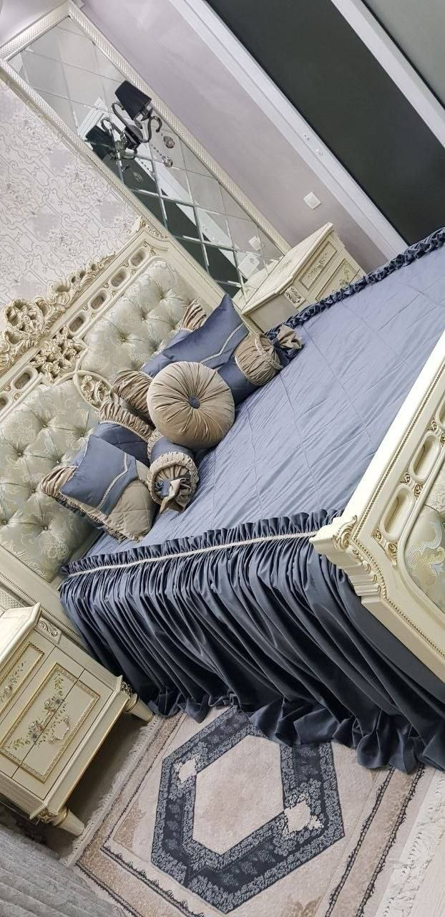

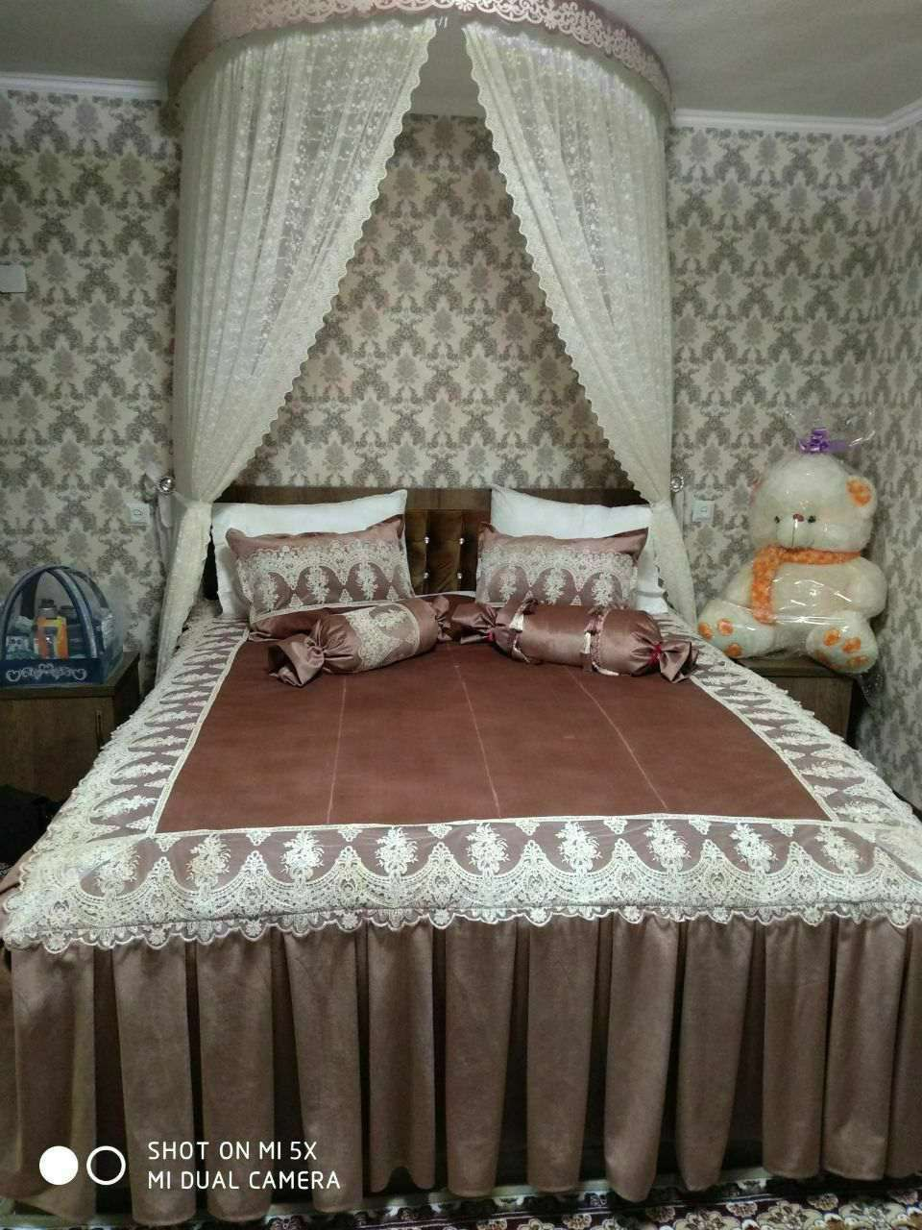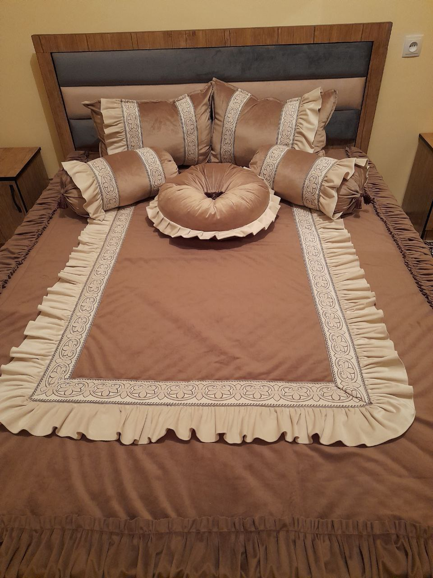

Nazorat uchun savollar:

1. Choyshab razmerlari?
2. Choyshab yon razmerlari va tikilishi?