



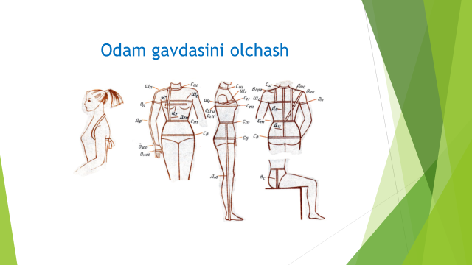

|  |  |  |  |  |  |  |
| --- | --- | --- | --- | --- | --- | --- |
| **Razmer** | **Xitoy razmeri** | **Turk razmeri** | **Ko’krak yarim aylanasi** | **Ko’krak aylanasi** | **Bel aylanasi** | **Bo’ksa aylanasi** |
| **42** | **S** | **36** | **41-42.5** | **82-85** | **66-69** | **92-95** |
| **44** | **M** | **38** | **43-44.5** | **86-89** | **70-73** | **96-98** |
| **46** | **L** | **40** | **45-46.5** | **90-93** | **74-77** | **99-101** |
| **48** | **XL** | **42** | **47-48.5** | **94-97** | **78-81** | **102-104** |
| **50** | **XXL** | **44** | **49-51** | **98-102** | **82-85** | **105-108** |
| **52** | **XXXL** | **46** | **51.5-53.5** | **103-107** | **86-90** | **109-112** |
| **54** | **XXXXL** | **48** | **54-56.5** | **108-113** | **91-95** | **113-116** |
| **56** | **XXXXXL** | **50** | **57-58.5** | **114-117** | **96-99** | **117-119** |

