**11-Mavzu: Tovar katalogi dizayni. Veb sahifa varaqalari dizaynini yaratish**

<https://habr.com/ru/post/44026/>

<http://www.dejurka.ru/tutorial/ui-tutorials/>

<http://ru.vectorboom.com/load/uroki/web_dizajn/7>

<https://www.seostop.ru/sozdanie-saita/html-css/shablon.html>

<https://photoshop-master.ru/lessons/web-and-app/professionalnyiy-maket-sayta-v-fotoshop.html>

<http://beloweb.ru/novichkam/kak-sdelat-maket-ili-dizayn-sayta-v-photoshop.html>

<https://stebnev-studio.ru/blog/sozdanie-maketa-sayta-v-photoshop-rukovodstv/>

<https://webdesguru.com/dizajn/lekcii/photoshop-lektor-dizajn-maketa-sajta-v-photoshop-detalnoe-rukovodstvo/>

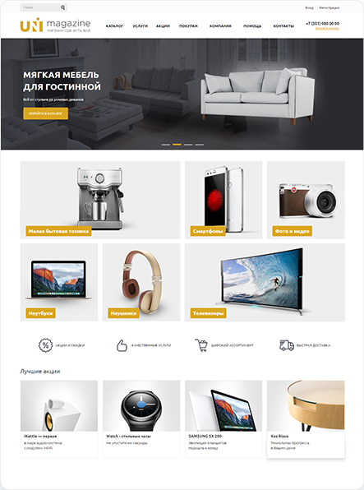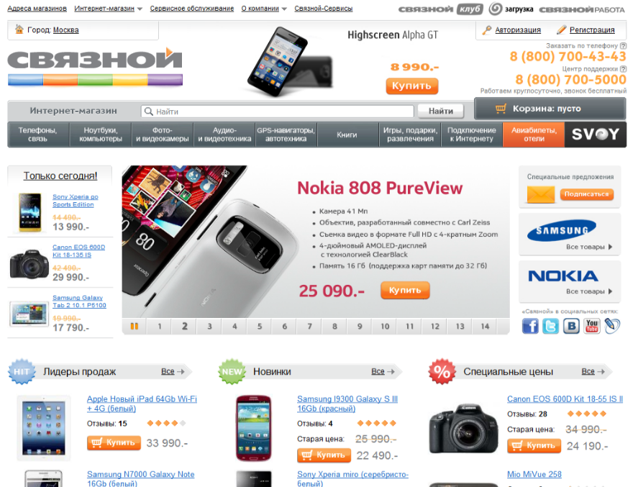

**Photoshopda biznes-veb-sayt uchun sahifa tuzilishi**

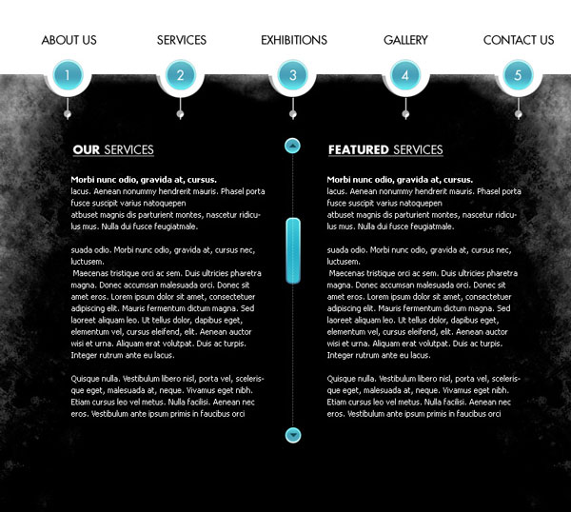

**1-qadam**

O'lchami 780 × 700 px va 72 dpi piksellar soniga ega yangi hujjat yarating (**Fayl> Yangi) (File>** **New**).

Yangi qavat yarating **(Shift + Ctrl + N).**Vositasi **to'g'ri burchakli Marquee**https://photoshop-master.ru/lessons/tools/marque.png**(Rectangular Marquee asbobini) (M)** zarur maydonlarni tanlash va vositasi bilan qora rang bilan ularni to'ldirib **moslaymiz**https://photoshop-master.ru/lessons/tools/zalivka.png**(G) (Bucket asbobini bo'yoq) .**

Shu qatlami vositasi to'g'risida **kinematikasini katta chodir**https://photoshop-master.ru/lessons/tools/Elliptical-Marquee.jpg**(Elliptical Marquee) (M)** , besh-tur tanlaganlarini va matbuot yaratish **, Delete** qora fonda ularni kesib (alohida-alohida har bir tanlash bo'yoq, so'ngra Delete tugmasini bosing) uchun.

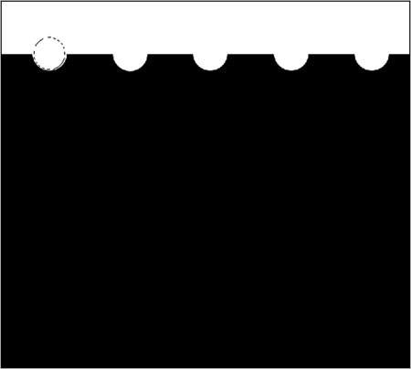

**2-qadam**

Yangi yaratilgan qavatni **nusxalash (Ctrl + J)** va uni qora fon yordamida qavat ostiga qo'ying. **Free Transform** Tool **(Ctrl + T)** yordamida qavatni rangini o'zgartirib o'ng tomonga siljiting. Buning uchun, bir qatlam uslubi amal **Overlay rangini (Color Overlay)** va rangini #AEAEAE tanlang.

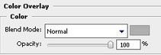

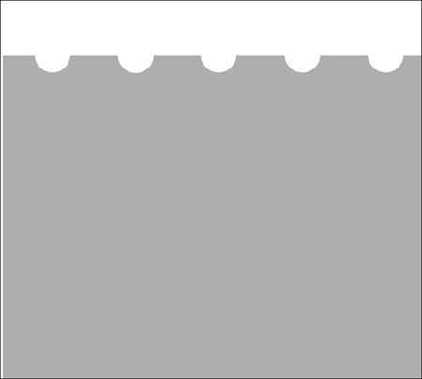 

**3-qadam**

Tanlang vositasi **Brush**https://photoshop-master.ru/lessons/tools/brush.png**(Brush Tool) (B)** Ushbu turdagi, ekran rasmini turganidek (u standart fırçaların biridir).

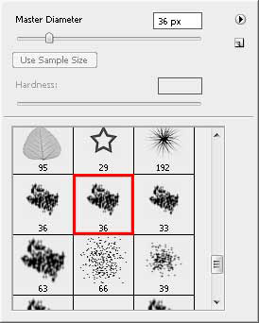

Belgilangan cho'tka yordamida orqa tarafdagi teshiklarning yoniga bir necha marta bosish kerak:

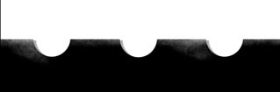

Endi vositasi tanlang **Dodge**https://photoshop-master.ru/lessons/tools/dodge.gif**(Dodge Tool) (Ey)** qora fonda screenshot vositasi va yurish ko'rsatilganidek, cho'tka bilan:

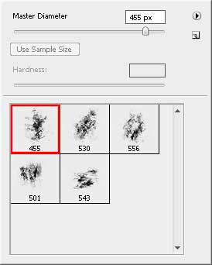

**4-qadam**

Internetda grunge cho'tkalarini toping, yangi qavat **(Shift + Ctrl + N)** yarating va oldindan tanlangan cho'tka yordamida qora fonda chizilgan joylarni chizamiz. Ushbu qatlamning shaffofligini 40% ga kamaytiring.

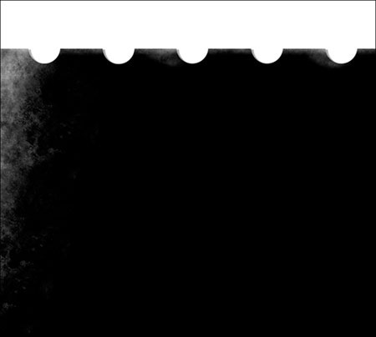 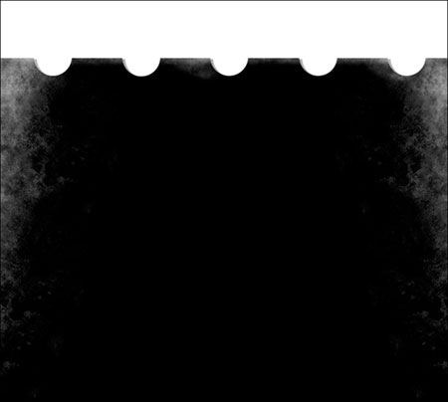

**5-qadam**

So'nggi yaratilgan qatlamni **(Ctrl + J)** nusxasini oling va uni 180 darajaga aylantiring **(Ctrl + T).**Skrinshotda ko'rsatilganidek, dublikatni joylashtiring:

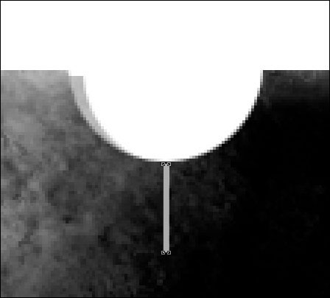

Vositasi **Rectangle**https://photoshop-master.ru/lessons/tools/rectangle.jpg**(Rectangle Tool) (U)** bir vertikal kulrang chiziq (#ACACAC) chizish.

Endi vositasi **Elips**https://photoshop-master.ru/lessons/tools/ellipse-tool.png**(Elips vositasi) (U)** , shu kulrang rangli (#ACACAC), deb liniyasi kichik doira chizish.

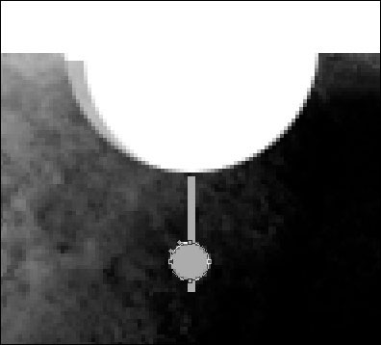

Shuningdek, vositasi **elips**https://photoshop-master.ru/lessons/tools/ellipse-tool.png**(Elips vositasi) (U)** bir kichik doira chizish. Ushbu doira oq rangda bo'lishi kerak.

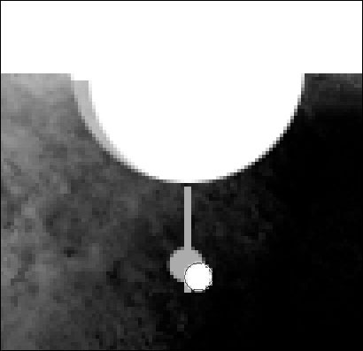

**6-qadam**

Sichqoncha kursorini oq va kulrang doiralar bilan qatlamlar orasiga qo'ying va kesish niqobini yaratish uchun **Alt** tugmachasini bosing . Shu sababli, oq doira kulrangning ichiga joylashtiriladi.

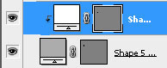

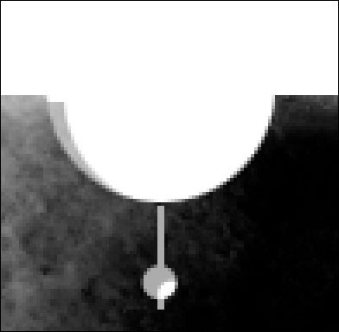

Yangi yaratilgan qatlamlarni guruhga joylashtiring **(Ctrl + G).**

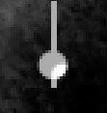

**7-qadam**

Guruhni to'rt marta takrorlang **(Ctrl + J)** va nusxalarini quyida ko'rsatilgan tartibda joylashtiring:

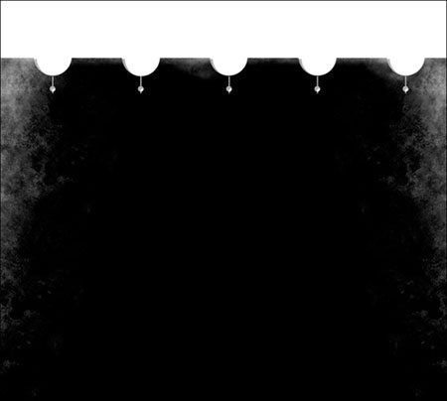

**8-qadam**

Endi sarlavhada tugmachani chizishingiz kerak. Buning uchun, bir vositasi foydalanish **kinematikasini katta chodir**https://photoshop-master.ru/lessons/tools/Elliptical%20Marquee.jpg**(Elips vositasi) (U).**

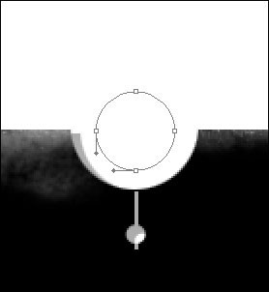

Tugma qatlamini **to'ldirish** parametrini 0% ga kamaytiring va unga **Outer Glow** qatlami uslubini qo'llang**:**

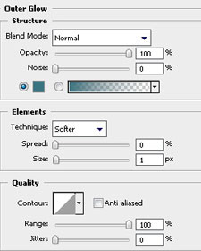

**Gradiyent ustki** qatlami uslubini ham qo'llang**:**

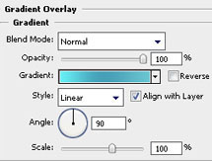

Qatlam uslubi parametrlari **Gradient ustki qismi:**

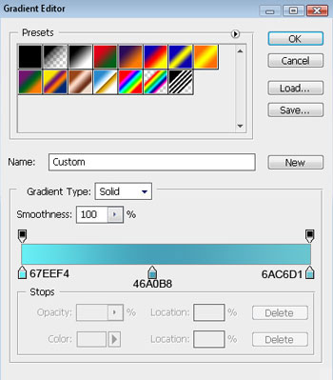

Shuningdek, **Strok** uslubini qo'shing **.**Konturni ochadigan oynada gradientni tanlang:

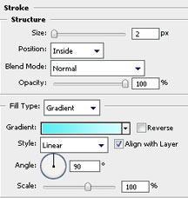

Strok Gradiyent parametrlari:

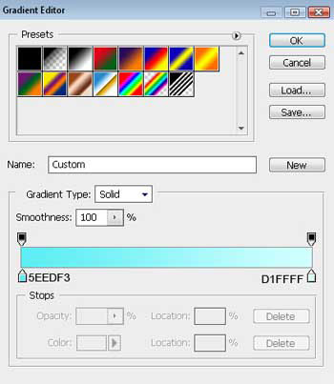

Natija:

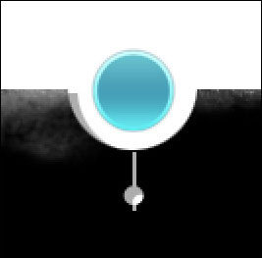

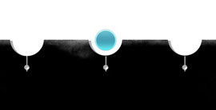

Qulaylik uchun menyu tugmachalari bilan barcha qatlamlarni guruhga qo'ying **(Ctrl + G).**Olingan guruhni to'rt marta takrorlang va nusxalarini ko'chiring:

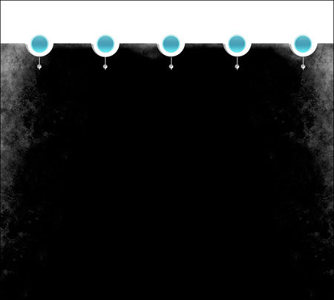

**9-qadam**

Endi menyu tugmachalarini raqamlang. **Matn**https://photoshop-master.ru/lessons/tools/T.jpg asbobini tanlang **(T),  Belgilar** palitrasini **(Oyna - Belgilar) oching** va undagi shrift va uning hajmini tanlang. Qolgan atributlarni sukut bo'yicha qoldiring yoki o'zingiz xohlagan narsani tanlang.

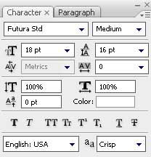 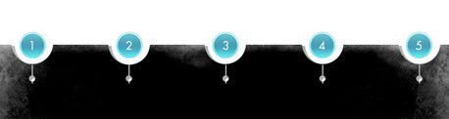

**10-qadam**

Endi menyu tugmalarining tepasida nomlarni yozing:

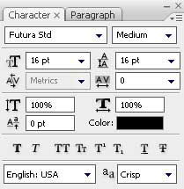 

**11-qadam**

Endi naqsh yarating. Yangi qatlam yaratish **(Shift + Ctrl + N)** 1 × 4 px va 72 dpi ni tanlang vositasi bir qarori bilan bir hajmini **qalam**https://photoshop-master.ru/lessons/les2625/pencil.jpg**(Qalam Vositachi) (B)** rang # 4C4C4C va xossa chizish:

https://photoshop-master.ru/lessons/les2625/32.jpg

https://photoshop-master.ru/lessons/les2625/33.jpg

Yaratilgan naqshdan to'qimalarni yarating **(Edit - Define Pattern).**

**12-qadam**

Vositasi **Rectangle**https://photoshop-master.ru/lessons/tools/rectangle.jpg**(Rectangle Tool) (U)** , vertikal chiziq chizilgan.

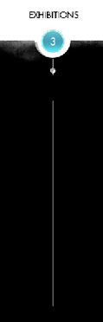

Vertikal chizig'i bo'lgan qatlam uchun **Fill** parametrini 0% ga kamaytiring va siz o'zingiz yaratgan teksturani qo'llang. Buning uchun **Pattern Overlay-ga** qavat uslubini qo'shing**.**

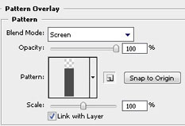 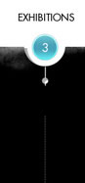

**13-qadam**

Yangi qatlam yaratish **(Shift + Ctrl + N)** 4 × 4 px bir hajmi va 72 dpi va vositasi **(qalam)**https://photoshop-master.ru/lessons/les2625/pencil.jpg**(Qalam Vositachi) (B)** boshqa naqsh chizish, rang # 25B0C3 bilan.

https://photoshop-master.ru/lessons/les2625/37.jpg

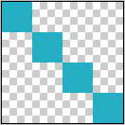

Yaratilgan naqshdan to'qimalarni yarating **(Edit - Define Pattern).**

**14-qadam**

Vositasi **Rounded Rectangle (**https://photoshop-master.ru/lessons/tools/round_rectangle.jpg**Rounded Rectangle bo'ladi vositasi) (U)** , bir oval shakl chizish. Uni nuqtali chiziq qatlami ostiga qo'ying:

https://photoshop-master.ru/lessons/les2625/39.jpg

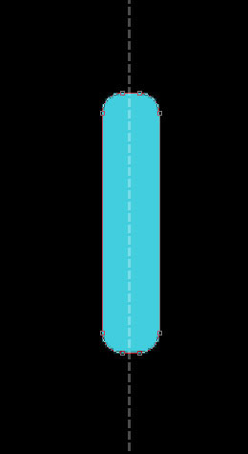

Oval shakl qatlami uchun **Gradiyent Overlay** qatlami uslubini qo'llang**:**

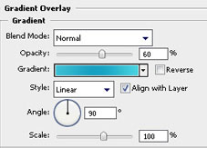

Qatlam uslubi parametrlari **Gradiyent ustki qismi:**

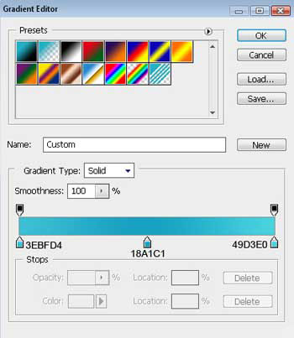

12-bosqichda o'zingiz yaratgan **tuzilma** bilan **Pattern Overlay** uslubini ham qo'llang.

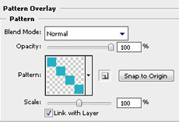

**Strok** gradient qatlamini to'ldirish uslubini ham qo'shing :

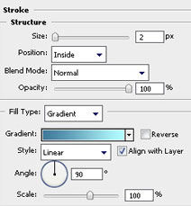

Qon tomir uchun gradient variantlaridan foydalaning:

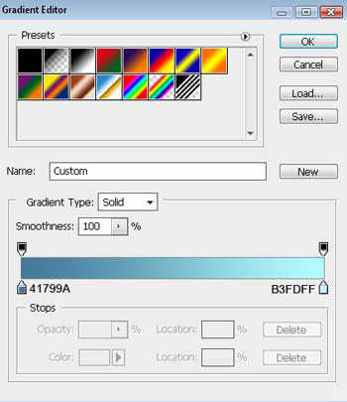

Natija:

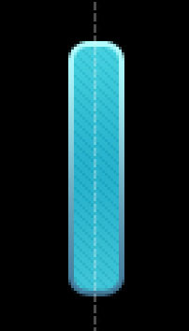

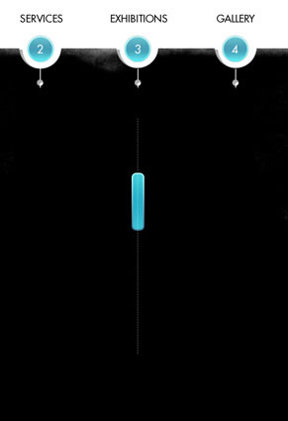

**15-qadam**

Vositasi **Elips**https://photoshop-master.ru/lessons/tools/ellipse-tool.png**(Elips vositasi) (U)** bir o'yin tugmasini chizish:

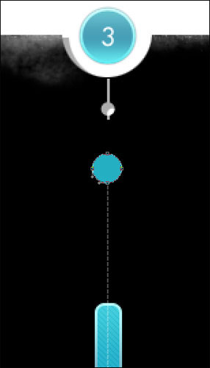

Ushbu tugma yordamida qatlamga quyidagi parametrlar bilan **Gradiyent Overlay** uslubini qo'llang:

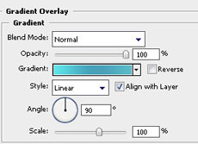 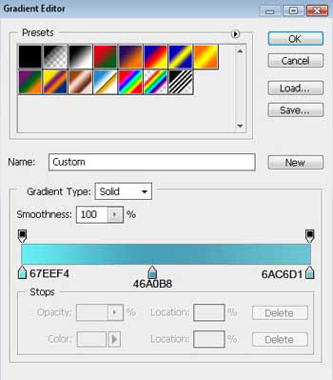

Shuningdek, uslubi qo'shish **Kontur** gradient to'ldiradi (Stroke) bilan:

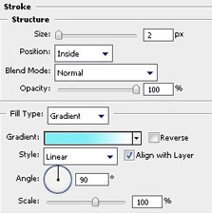 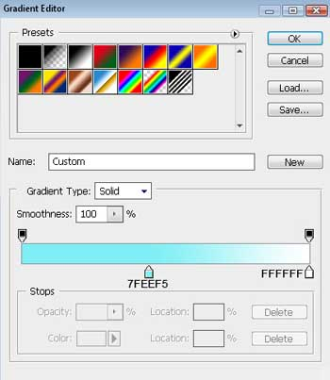

Natija:

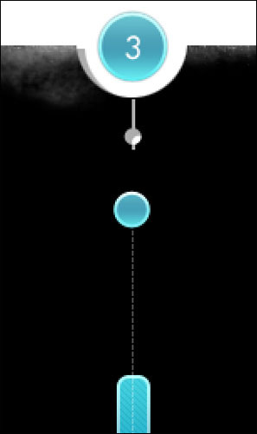

**16-qadam**

Vositasi **qalam**https://photoshop-master.ru/lessons/les2625/pencil.jpg**(Qalam Vositachi) (B)** tugmasini bir o'q chizish. Buning uchun yangi qavat **(Shift + Ctrl + N)** yarating va # 124E58 rangidan foydalaning.

https://photoshop-master.ru/lessons/les2625/54.jpg



O'yin tugmachasiga tegishli barcha qatlamlarni guruhga joylashtiring **(Ctrl + G),** guruhni takrorlang **(Ctrl + J)** , uni vertikal ravishda siljiting **(Ctrl + T)** va nusxasini pastga tushiring:

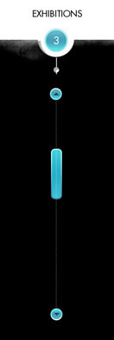

**16-qadam**

Menyu ostida tarkibga ikkita maydon qo'shing:

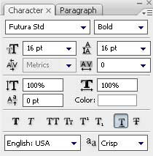 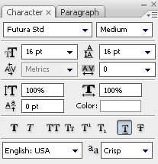



Tarkib ostidagi ikkita sohada matn qo'shing:

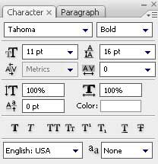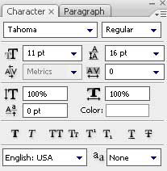

**Yakuniy natija:**

